
Practice Training
The Practice will close this quarter of 2023 for half day training from 1.00pm on:
Thursday 22nd August

We thank you in advance for your patience on these dates whilst we undertake necessary training and development.

Our usual opening hours:
Monday | 08:00-18:30
Tuesday | 08:00-18:30
Wednesday | 08:00-18:30
Thursday | 08:00-18:30
Friday | 08:00-18:30
Saturday | CLOSED
Sunday | CLOSED

Patient Participation Group (PPG)

Following our PPG meeting in April, a member suggested that it would be great to update our website with the PPG meeting minutes and to start a fundraiser for a new phlebotomy couch to help towards creating a new consulting room.
We are currently reviewing our staff training around our website to be able to use it in the best way that benefits both our patients and us. We also hope to have the fundraiser ready to go soon so we can expand our space and offer a wider service to our patients. Thank you to the member for suggesting this. We welcome feedback from our PPG and patients.
If you are interested in becoming a member of our PPG, please email us on somicb.enquiries-creechmc@nhs.net or call us and speak to Nandini McCulloch, Practice Manager.

Download the NHS App today!
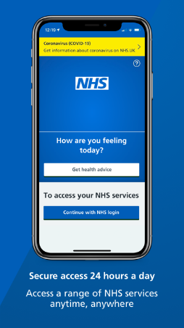

Prostate Cancer UK
At Creech Medical Centre we are proactively trying to identify men at risk of prostate cancer and those showing early signs.
The 3 main groups of men who are at high risk of developing prosate cancer are
- All men aged 50 or above
- Have a family history of prostate cancer over the age of 45
- Black men aged 45 or over

You can check your risk here at https://prostatecanceruk.org/risk-checker

Men who have unexplained urinary symptoms please contact reception to arrange a further discussion.
For men aged 50 or over with concerns but with no current urinary symptoms please follow this link.
https://www.nhs.uk/conditions/prostate-cancer/should-i-have-psa-test/

New staff at Creech Medical Centre

Olena Rudyuk – Practice Nurse / Diabetes Nurse joined our team at the July after our previous Practice Nurse Heather retired. Olena has a wealth of experience and is extremely proactive and understanding. Faith Glanville-Hodge also joined us in May/June as a Receptionist. Please welcome them and continue to support our staff by giving your feedback.

Our Clinical Staff
Doctors
Dr Willemijn Balder – Clinical Lead
Dr Laurence Quinn
Dr Chibueze Mbanaso (Dr Mb)
Dr Adetutu Osibanjo (Dr Tutu)
Advanced Clinical Practitioners
Mrs Deborah Wilson
Mr Mike Garland
Practice Nurses
Mrs Caroline Welch – Lead Nurse
Mrs Olena Rudyuk
Mrs Alison Nearn
HCA/Phlebotomist
Miss Laura Peddie
Ms Emma Pashley

45 DNAs in July – please let us know if you are unable to attend your appointment

Appointments provided in the last 4 weeks:
1540 face-to-face
825 telephone





Total number of telephone calls in July: 6993 and average queue time = 1m10s

Open Afternoon in October 2023

We will be holding an open afternoon for patients to visit us between 4pm and 6pm. This gives you an opportunity to ask us questions about the surgery and Symphony Healthcare. We are hoping other organisations such as the Integrated Care Board (ICB) and our PPG group, NHS Digital and MyWay Diabetes. Date to be confirmed.
More details to follow. Watch this space!

Patient Feedback
We welcome feedback from our patients following your experiences at the surgery. Many of you will receive a text message after an appointment asking for your feedback; please take 2 short minutes to complete this. We review this regularly and try to make changes that are possible based off of this information.
You can also leave feedback on google reviews. We are proud to have 4* rating.
If you do not have access to the internet, you can leave feedback verbally or write in to us.
Thank you to everyone who has taken the time to do this so far.


