
Practice Training
The Practice will close this quarter of 2023 for half day training from 1.00pm on:
Wednesday 13th of December

We thank you in advance for your patience on these dates whilst we undertake necessary training and development.

Our usual opening hours:
Monday | 08:00-18:30
Tuesday | 08:00-18:30
Wednesday | 08:00-18:30
Thursday | 08:00-18:30
Friday | 08:00-18:30
Saturday | CLOSED
Sunday | CLOSED

#Help4All – Connect Somerset
Everyone is impacted by the cost-of-living rising which can put extra pressure on families. Somerset voluntary, community and public services are here to help. We’ve listed some of the most popular services and support that may be useful for you to know about. For links, simply visit: www.connectsomerset.org.uk
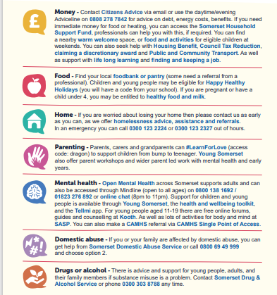

Download the NHS App today!
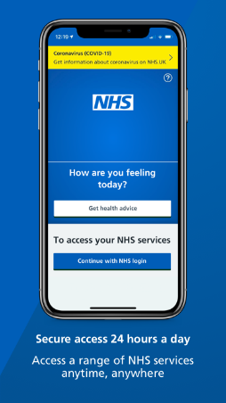

Kooth - Online Mental Health Service for children and young people (CYP)
Kooth is one of the only digital mental health service accredited by the British Association of Counsellors and Psychotherapists, and offers anonymous and professional support, peer support, and self-directed support for CYP. There is no waiting list, no minimum criteria to access support, no referral is required and the service is free to use. The service is accessible via www.kooth.com.

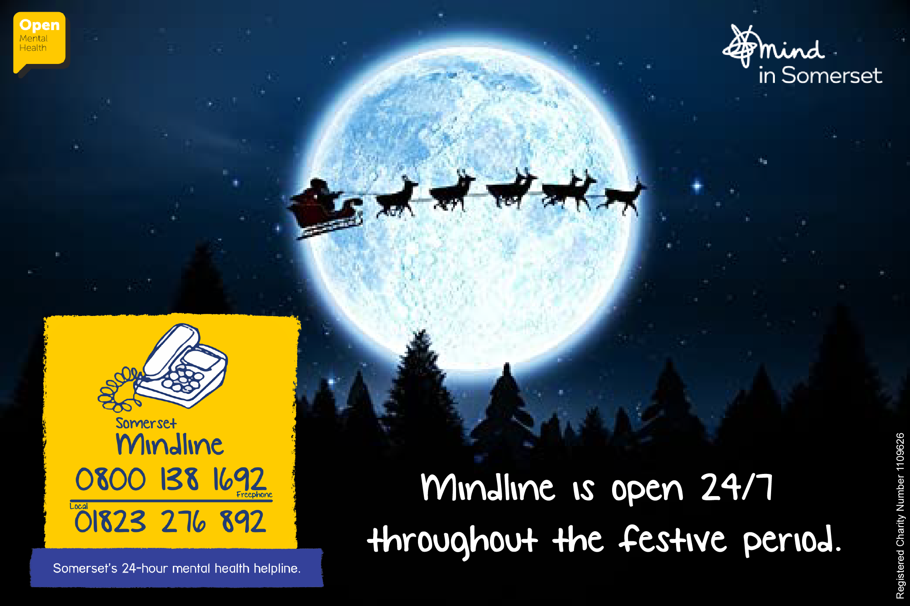
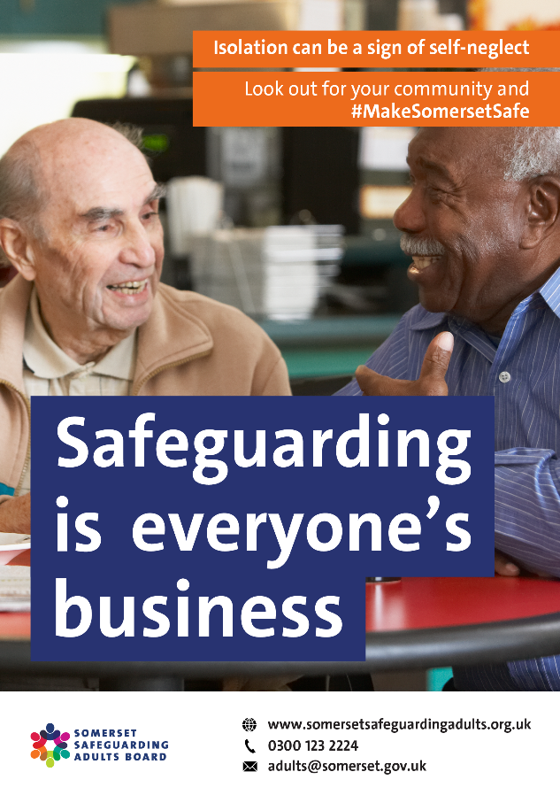

Our Clinical Staff
Doctors
Dr Willemijn Balder – Clinical Lead
Dr Laurence Quinn
Dr Chibueze Mbanaso (Dr Mb)
Dr Adetutu Osibanjo (Dr Tutu)
Advanced Clinical Practitioners
Mrs Deborah Wilson
Mr Mike Garland
Practice Nurses
Mrs Caroline Welch – Lead Nurse
Mrs Olena Rudyuk
Mrs Alison Nearn
HCA/Phlebotomist
Ms Emma Pashley
Clinical Pharmacists
Funmi Lampejo
Charles Nicholas

106 DNAs in October – please let us know if you are unable to attend your appointment

Appointments provided in October:
2327 face-to-face
776 telephone





Total number of telephone calls in August: 4974 and average queue time = 3m 50s
NHS APP
The NHS App team has been redesigning the App to make it easier for patients to find the services they need.
Based on user feedback, the homepage and other high-level screens have been redesigned to simplify navigation and make the NHS App more intuitive. As a result of the changes, some services may move but all will be available to patients as before.
The settings within the NHS App will also remain the same and patients will continue to receive messages before and after the update.
Rollout of the ‘new look’ will begin in the coming weeks and patients will be prompted to update the version on their device(s).
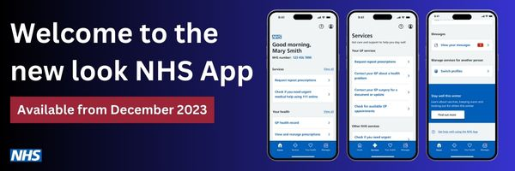
Merry Christmas and a Happy and Healthy New Year
We would like to wish all of our patients a Merry Christmas and a Happy New Year! We are only closed on bank holidays and all other days will be our usual working hours. We are closed on: Monday 25th December Tuesday 26th December Monday 1st January 2024 Please make sure to order your medication in time – we recommend doing this in your usual way when you have 2 weeks supply left. If you require urgent medical attention whilst we are closed please contact 111 or if life threatening 999. Further self-help advice is available on the NHS website www.nhs.uk


