
Practice Training
The Practice will close this quarter of 2024 for half day training from 12.00pm on:
Tuesday 27th of February 2024
We thank you in advance for your patience on these dates whilst we undertake necessary training and development.

Our usual opening hours:
Monday | 08:00-18:30
Tuesday | 08:00-18:30
Wednesday | 08:00-18:30
Thursday | 08:00-18:30
Friday | 08:00-18:30
Saturday | CLOSED
Sunday | CLOSED

Staff News

We would like to welcome Megan to our team. Megan is a Nurse Associate who will be starting with us on the 10th of January. Her role will cover a wide range of nursing tasks, including, blood taking, dressings, giving immunisations, conducting ECGs, and other clinical services. We hope that you give Megan a warm welcome as she progresses with her new role.

Dry January Campaign

Do you fancy a challenge for January? Do you want to do something to improve your health?
If you answer yes to either of these, then maybe Dry January could be a good challenge to try this year. Dry January was set up in order to support people across the country to change their relationship with alcohol by stopping drinking for a month.

The idea is to have a total body and mind reset. It is proven to show better sleep and a mental health boost. On top of this it is also a good way to save your money and time. For further information, please visit: www.alcoholchange.org.uk If you think you are drinking too much and feel you need support, please contact us for an appointment with our clinicians. You can need support at any age.


Download the NHS App today!
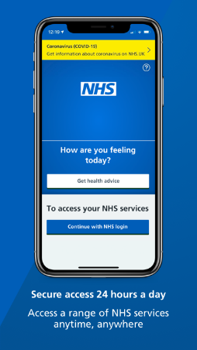

My Planned Care – NHS Website for waiting times for local NHS services.
My Planned Care gives you advice and support while you wait and helps you to prepare for your hospital consultation, treatment, or surgery. This includes giving you information about waiting times at your hospital and other supporting and local services while you wait.
This site is updated weekly and can be viewed by anyone, which means you, your family or carer as well as your NHS team can all see the latest information.
Please visit https://www.myplannedcare.nhs.uk/swest/somerset/ and select the department that you wish to view waiting time information about.

NHS Quicker App

This free app provides live waiting times for the emergency departments (A&E) and urgent care services in Somerset, Devon and Cornwall. Waiting times from the nearest five emergency departments/urgent care centres are shown. At least one emergency department will always appear in the list irrespective of geographical distance from the user. Emergency departments can be busy. If you have a minor injury or condition which you feel needs medical attention, but it is not an emergency, it may be quicker to be seen at one of the urgent care services.
https://nhsquicker.co.uk/app/app/#/
Our Clinical Staff
Doctors
Dr Willemijn Balder – Clinical Lead
Dr Laurence Quinn
Dr Chibueze Mbanaso (Dr Mb)
Dr Adetutu Osibanjo (Dr Tutu)
Advanced Clinical Practitioners
Mrs Deborah Wilson
Mr Mike Garland
Practice Nurses
Mrs Caroline Welch – Lead Nurse
Mrs Olena Rudyuk
Mrs Alison Nearn
HCA/Nurse Associate
Ms Emma Pashley
Mrs Megan Owens
Clinical Pharmacists
Funmi Lampejo
Charles Nicholas

50 DNAs in December – please let us know if you are unable to attend your appointment

Appointments provided in December:
1295 face-to-face
663 telephone





Total number of telephone calls in November: 6325 and average queue time = 3m 51s

