
Practice Training
The Practice will close this quarter of 2023 for half day training from 1.00pm on:
Wednesday 13th of December

We thank you in advance for your patience on these dates whilst we undertake necessary training and development.

Our usual opening hours:
Monday | 08:00-18:30
Tuesday | 08:00-18:30
Wednesday | 08:00-18:30
Thursday | 08:00-18:30
Friday | 08:00-18:30
Saturday | CLOSED
Sunday | CLOSED

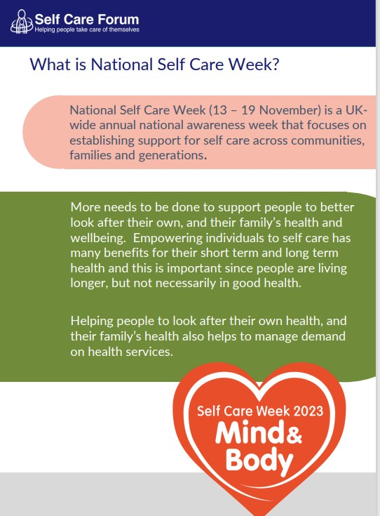
Here are some other self-care messages we encourage you to adopt and promote during Self Care Week:
- Take vitamin D supplements, particularly important as daylight hours decrease
- Maintain good nutrition and regular exercise to support general wellbeing and help maximize people’s immunity.
- Adopt positive lifestyle choices
- Support mental wellness, including maintaining social connections, outdoor exercise, work-life balance etc
- Find out how to manage minor and long-term health conditions
- Understand the importance of vaccinations and screening.

Download the NHS App today!
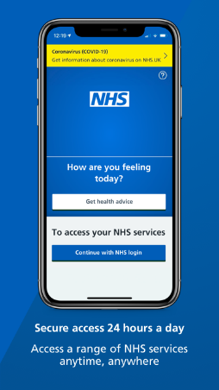

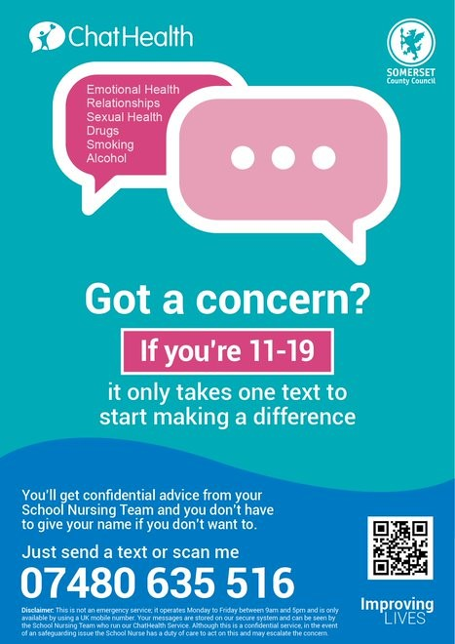
Annual General Meeting

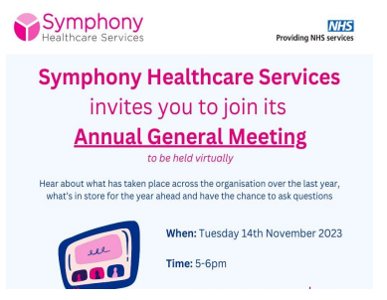
Please visit our website for the link to join - Symphony Healthcare Services - Annual General Meeting – Creech Medical Centre

Our Clinical Staff
Doctors
Dr Willemijn Balder – Clinical Lead
Dr Laurence Quinn
Dr Chibueze Mbanaso (Dr Mb)
Dr Adetutu Osibanjo (Dr Tutu)
Advanced Clinical Practitioners
Mrs Deborah Wilson
Mr Mike Garland
Practice Nurses
Mrs Caroline Welch – Lead Nurse
Mrs Olena Rudyuk
Mrs Alison Nearn
HCA/Phlebotomist
Miss Laura Peddie
Ms Emma Pashley
Clinical Pharmacists
Funmi Lampejo
Charles Nicholas

106 DNAs in October – please let us know if you are unable to attend your appointment

Appointments provided in October:
2327 face-to-face
776 telephone





Total number of telephone calls in August: 4974 and average queue time = 3m 50s
Are you a military veteran?
During the last few weeks there has been much on the media about the conflict in the Middle East and elsewhere around the world. We understand that for some of our Veterans this could be traumatic and triggering. If you feel like you need some additional support, then please either contact the surgery, Mindline Somerset 01823 276892 or 0800 138 1692.
Alternatively, attending a Veteran’s Breakfast club can provide camaraderie and support. Find your nearest one The Official Armed Forces & Veterans Breakfast Clubs Network (afvbc.net)
Please let us know if you are a military veteran. You are a veteran whether you have served for 1 year or 40+ years. It is important to have this information on your medical records so that we can make sure all services available are offered to you should you require them.
Accurx – Online Patient Triage
We are now more accessible than ever with our online patient triage system. This can be accessed via our website homepage 24/7 - Home - Creech Medical Centre Once submitted, your problem is triaged by a member of our clinical team within 3 working days. They can offer medical advice over the telephone, via text or simply advise you to book a routine appointment within a certain timeframe.
This is for routine problems and should never be used when you require urgent same day attention or for prescription requests.
Thank you! – Creech Information Evening
We would like to say thank you to everyone who was able to attend our information evening and for the feedback that was given. We really appreciate the time you took to come along to find out more about some of the local services that are available to you.

