
Practice Training
The Practice will close this quarter of 2024 for half day training from 12.00pm on:
Tuesday 26th of November 2024
We thank you in advance for your patience on these dates whilst we undertake necessary training and development.

Our usual opening hours:
Monday | 08:00-18:30
Tuesday | 08:00-18:30
Wednesday | 08:00-18:30
Thursday | 08:00-18:30
Friday | 08:00-18:30
Saturday | CLOSED
Sunday | CLOSED

Flu and RSV Vaccines
We are still offering flu vaccinations to eligible patients. This includes carers and pregnant patients.

The RSV vaccine helps protect against respiratory syncytial virus (RSV), a common virus that can make babies and older adults seriously ill. It's recommended during pregnancy and for adults aged 75 to 79. Our RSV clinics will be starting from the 22nd of November. If you are between the age of 75 and 79 or pregnant please contact us to book your appointment.

Joy – Social Prescribing
What is Social Prescribing?
Social prescribing is a way GPs, nurses, link workers and other health and care professionals can refer people to a range of local services to meet their non-clinical needs. The aim is to take a more holistic approach to a person's health and wellbeing by focusing on what matters to them. Social prescribing is a key component of Universal Personalised Care and its rollout is actively supported by the Long Term Plan NHS England.
How it works
Social prescribing enables healthcare professionals and/or link workers to refer patients to community services. It's a way patients without medical needs can get support whilst the healthcare professionals keep their own time free for patients with immediate health concerns.
We have access to a Health coaching team that can help with Social prescribing and health improvement goals. https://www.thejoyapp.com/what-is-social-prescribing

Download the NHS App today!
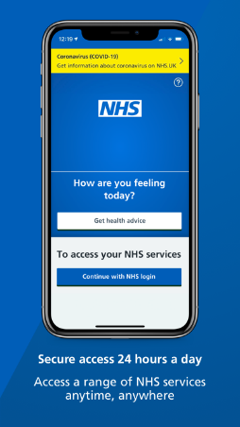

World Antimicrobial Resistance Awareness Week next month ( 18-25th November) European Antibiotic Awareness Day on the 18th November.
WAAW takes place from 18 to 24 November each year and is led globally by the World Health Organization (WHO). It aims to increase awareness of global antimicrobial resistance (AMR) and to encourage best practices among the public, health workers and policy makers to avoid the further emergence and spread of drug-resistant infections. Antimicrobial resistance (AMR) occurs when bacteria, viruses, fungi and parasites change over time and no longer respond to medicines, making infections harder to treat and increasing the risk of disease spread, severe illness and death. As a result of drug resistance, antibiotics and other antimicrobial medicines become ineffective and infections become increasingly difficult or impossible to treat. For more information visit World AMR Awareness Week
The Annual Symphony General Meeting
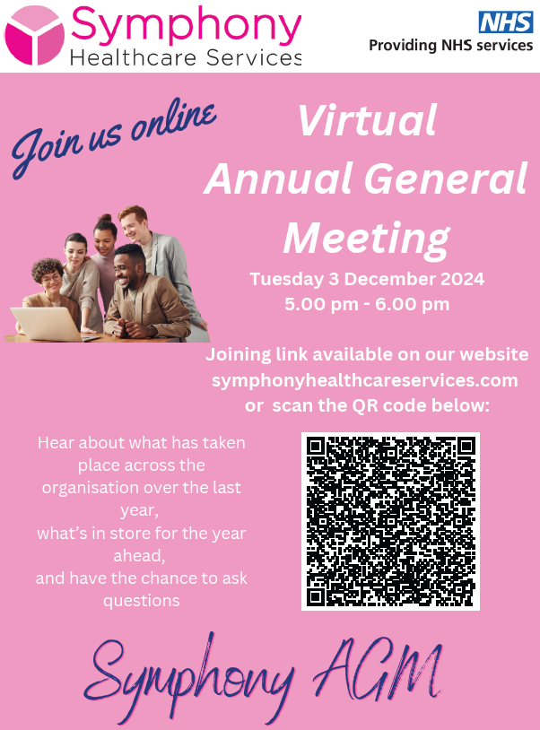
Our Clinical Staff
Doctors
Dr Willemijn Balder – Clinical Lead
Dr Laurence Quinn
Dr Chibueze Mbanaso (Dr Mb)
Dr Nick Bridgemohan
Advanced Clinical Practitioners
Mrs Deborah Wilson
Mr Mike Garland
Practice Nurses
Mrs Caroline Welch – Lead Nurse
Mrs Olena Rudyuk
HCA/Nurse Associate
Ms Emma Pashley
Mrs Megan Owens
Clinical Pharmacists
Chinwe Ukachu

68 DNAs in October – please let us know if you are unable to attend your appointment

Appointments provided in December:
1573 face-to-face
704 telephone





Total number of telephone calls in October: 6340 and average queue time = 3m 7s

