
Practice Training
The Practice will close this quarter of 2023 for half day training from 1.00pm on:
Tuesday 31st of October
Wednesday 13th of December

We thank you in advance for your patience on these dates whilst we undertake necessary training and development.

Our usual opening hours:
Monday | 08:00-18:30
Tuesday | 08:00-18:30
Wednesday | 08:00-18:30
Thursday | 08:00-18:30
Friday | 08:00-18:30
Saturday | CLOSED
Sunday | CLOSED

NHS App & Text Messages
If you use the NHS App you will now receive messages from the practice through the NHS App. This is a secure way of receiving and sending messages about your care. This may include:
- Appointment Reminders / Changes
- Test results
- Asking to book an appointment
- Messages from GPs and other clinical staff

To check your messages:
- Log in to the NHS app
- Go to View your messages
- Select, View message from your GP surgery and other NHS services
- Then select (GP surgery name)

Get NHS App notifications when we send you a message

To turn on notifications:
1. Log in to the NHS app
2. Go to More
3. Select Account and settings
4. Then select Manage notifications.
5. Use the toggle to turn notifications on or off.

For NHS App support, please contact NHS App help and support on the NHS website.

Download the NHS App today!
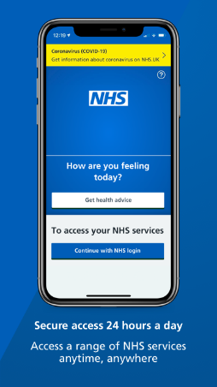

Open Afternoon 31st of October 2023

We will be holding an open afternoon for patients to visit us between 4pm and 6pm on the 31st of October. This gives you an opportunity to ask us questions about the surgery and about Symphony Healthcare Services. Other organisations such, NHS Digital, Village Agents, Health coaches, and our PPG will be attending to provide you with information and answer questions about their services. There will be refreshments and a raffle!

Annual General Meeting

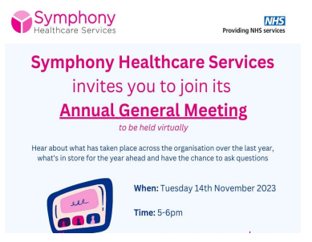
Please visit our website for the link to join - Symphony Healthcare Services - Annual General Meeting – Creech Medical Centre

Movember

Men’s Health Awareness Month November is the month to take on vital fundraising for mental health, suicide, prostate cancer and testicular cancer for men. For more information or to take part, visit: uk.movember.com

Our Clinical Staff
Doctors
Dr Willemijn Balder – Clinical Lead
Dr Laurence Quinn
Dr Chibueze Mbanaso (Dr Mb)
Dr Adetutu Osibanjo (Dr Tutu)
Advanced Clinical Practitioners
Mrs Deborah Wilson
Mr Mike Garland
Practice Nurses
Mrs Caroline Welch – Lead Nurse
Mrs Olena Rudyuk
Mrs Alison Nearn
HCA/Phlebotomist
Miss Laura Peddie
Ms Emma Pashley
Clinical Pharmacists
Funmi Lampejo
Charles Nicholas

84 DNAs in September – please let us know if you are unable to attend your appointment

Appointments provided in August:
1903 face-to-face
873 telephone






Total number of telephone calls in August: 4114 and average queue time = 3m 47s

