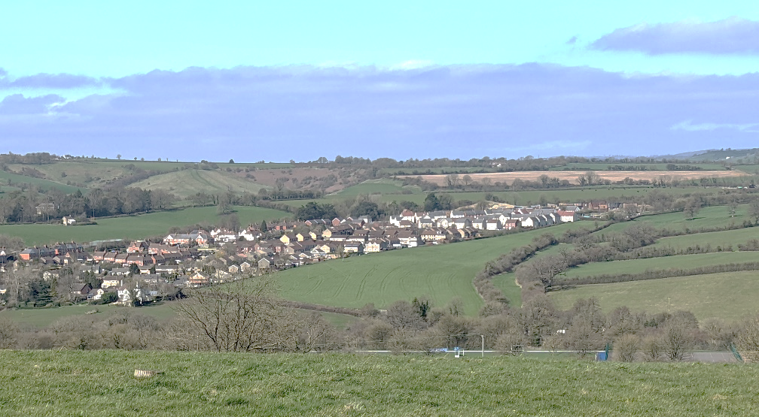
Practice Training
The Practice will close this quarter of 2023 for half day training from 1.00pm to 4pm on:
Tuesday 31st of October

We thank you in advance for your patience on these dates whilst we undertake necessary training and development.

Our usual opening hours:
Monday | 08:00-18:30
Tuesday | 08:00-18:30
Wednesday | 08:00-18:30
Thursday | 08:00-18:30
Friday | 08:00-18:30
Saturday | CLOSED
Sunday | CLOSED

Open Afternoon 31st of October 2023

We will be holding an open afternoon for patients to visit us between 4pm and 6pm on the 31st of October. This gives you an opportunity to ask us questions about the surgery and about Symphony Healthcare Services. Other organisations such, NHS Digital, Village Agents, Health coaches, and our PPG will be attending to provide you with information and answer questions about their services. There will be refreshments and a raffle!

Flu Season
Are you over 65 years old? Or Are you aged 18-64 years old with an underlying health condition which makes you at risk? Or Do you have a 2 or 3 year old? If yes, please call us on 01823 282147 between 2pm and 4pm to arrange a time in our clinic dates.
We have recently sent out our text invites. If you received this, you are eligible. If you are unsure, please contact reception. Please let us know if you wish to decline the vaccine or if you have had this done elsewhere so we can update your medical records. We are not currently offering the covid vaccination

Download the NHS App today!
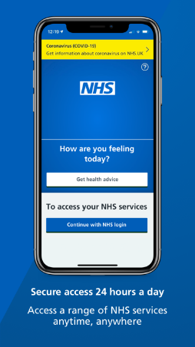

Carers Support Meeting – SPARKS – Life Café – Creech St Michael
Sparks Taunton will be holding their first carers support meeting at the Life Café in Creech St Michael on the 20th of October at 10:30 am
The Carers Group gives unpaid carers of friends and family members the opportunity to take a much needed break, socialise with other carers, share experiences, laugh, cry and find out how to access local information, resources, and other sources of support.

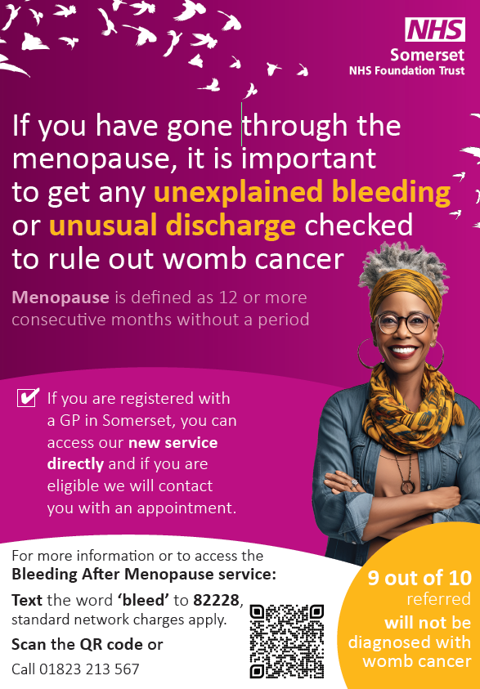
Our Clinical Staff
Doctors
Dr Willemijn Balder – Clinical Lead
Dr Laurence Quinn
Dr Chibueze Mbanaso (Dr Mb)
Dr Adetutu Osibanjo (Dr Tutu)
Advanced Clinical Practitioners
Mrs Deborah Wilson
Mr Mike Garland
Practice Nurses
Mrs Caroline Welch – Lead Nurse
Mrs Olena Rudyuk
Mrs Alison Nearn
HCA/Phlebotomist
Miss Laura Peddie
Ms Emma Pashley

73 DNAs in August – please let us know if you are unable to attend your appointment

Appointments provided in August:
1656 face-to-face
939 telephone





Total number of telephone calls in August: 4772 and average queue time = 4m 36s
National GP Survey 2023

National GP Survey Results We would like to thank our patients who took the time to complete the GP national survey questionnaire.

84% of the patients surveyed reported their overall experience of the practice as good.

We were above average when compared to ICS results in all areas. 272 surveys were sent out and 105 surveys were returned.

93% found the receptionists at the practice to be helpful.

81% were satisfied with the appointment they were offered compared to 72% nationally.

89% said the healthcare professional they saw or spoke to was good at listening to them during their last appointment.

66% were satisfied with the general practice appointment times available. Compared to 53% nationally.

We always welcome feedback. This can be done via the texts you receive after an appointment or we have a suggestion box in reception if you wish to complete a form when visiting us. For more information regarding the GP National Survey please visit www.gp-patient.co.uk


